**Assignment**

**CSA0814– Python Programming**

|  |  |
| --- | --- |
| **Register Number** | **192324301** |
| **Name** | **D.Harika** |

**Title: Email Attachment Downloader**

**Problem Statement: Email Attachment Downloader**

**Code:**

**detach_dir = 'c:/downloads'**

**m = imaplib.IMAP4_SSL("imap.gmail.com")**

**m.login('hello@gmail.com','3323434')**

**m.select("[Gmail]/All Mail")**

**resp, items = m.search(None, "(UNSEEN)")**

**items = items[0].split()**

**for emailid in items:**

**resp, data = m.fetch(emailid, "(RFC822)")**

**email_body = data[0][1]**

**mail = email.message_from_string(email_body)**

**temp = m.store(emailid,'+FLAGS', '\\Seen')**

**m.expunge()**

**if mail.get_content_maintype() != 'multipart':**

**continue**

**print "["+mail["From"]+"] :" + mail["Subject"]**

**for part in mail.walk():**

**if part.get_content_maintype() == 'multipart':**

**continue**

**if part.get('Content-Disposition') is None:**

**continue**

**filename = part.get_filename()**

**att_path = os.path.join(detach_dir, filename)**

**if not os.path.isfile(att_path) :**

**fp = open(att_path, 'wb')**

**fp.write(part.get_payload(decode=True))**

**fp.close()**

**return HttpResponse('check folder')**

**Output Screen Shots:**

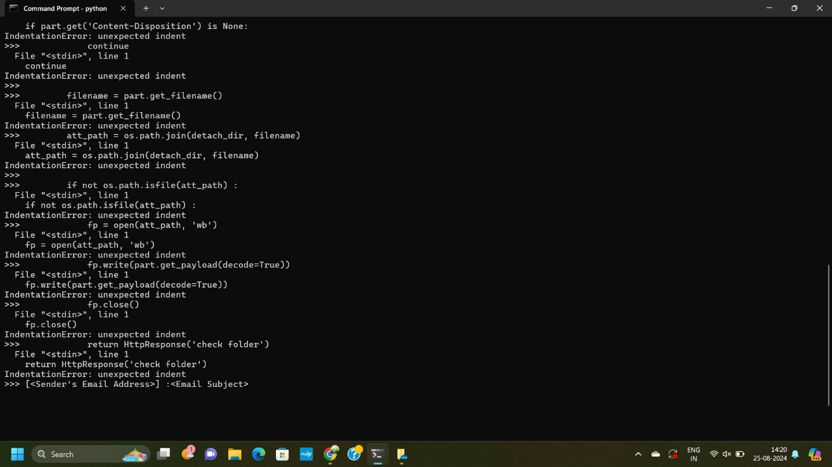

**Conclusion:**

**This script is functional for retrieving and saving attachments from unseen emails in a Gmail account. However, there are a few potential issues or improvements:**

* **Security Concern: The script stores the email password in plain text, which is a security risk. It's better to use a more secure authentication method like OAuth2.**
* **Error Handling: There is no error handling, which means any issue (e.g., network problems, permission issues, or missing attachments) could cause the script to fail without a clear message.**
* **Redundant Code: The return HttpResponse('check folder') line will only execute once during the first iteration of the loop, and it’s outside the context of a web framework (e.g., Django), so it might be misplaced or need to be replaced with a more appropriate completion signal for this script context.**
* **Logging: Adding logging would help in tracking the script's progress and diagnosing issues.**